**ASSIGNMENT – III**

1. **Create the table MYEMP1 (with the following structure) in Oracle RDBMS.**

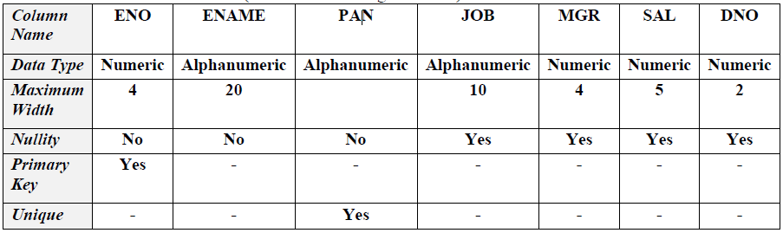

**Ans.** create table MYEMP1

(

ENO number(4),

ENAME varchar2(20) not null,

PAN varchar2(20) unique not null,

JOB varchar2(10),

MGR number(4),

SAL number(5),

DNO number(2)

);

alter table MYEMP1

add constraint pk_myemp1 primary key(ENO);

1. **Add bonus Column to myemp1 table. Take bonus as of type number with size 10.**

**Ans.** alter table MYEMP1 add bonus number(10);

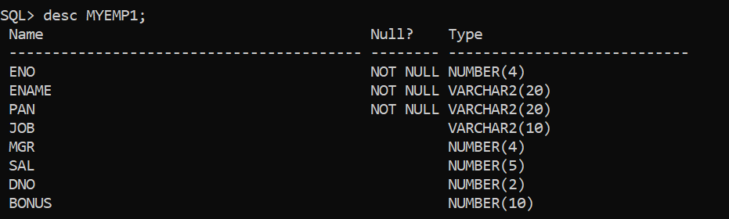

1. **a) Create a table Depart with the columns dept_id, dept_name, location_name where dept_id is primary key.**

**Ans.**  create table Depart

(

dept_id number(4),

dept_name varchar2(33),

location_name varchar2(33)

);

alter table Depart

add constraint pk_dep primary key(dept_id);

**b) Create another table Employ with the columns empid, name, salary, address, hire_date, department_no where empid is primary key.**

**Ans.**  create table Employ

(

empid number(4),

name varchar2(33),

salary number(8),

address varchar2(33),

hire_date varchar2(10),

department_no number(6)

);

alter table Employ

add constraint pk_emp primary key(empid);

* **Give appropriate names to all the constraints being imposed on both the tables. Insert at least 3 rows in departments table. Insert at least 5 rows in the employees table with different department names.**

**Ans.** insert into Depart values(11,'Magic','Wizarding World');

insert into Depart values(22,'Internalisation','Mind');

insert into Depart values(33,'Nurture','Heart');

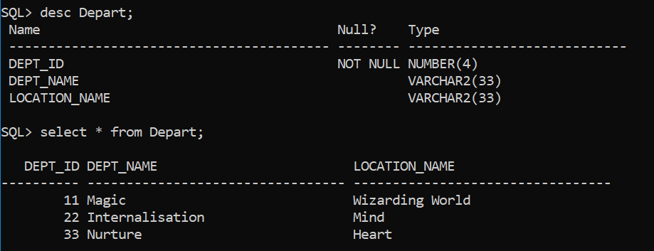

insert into Employ values(000,'Metatron',000,'The Dreamer',000,444);

insert into Employ values(111,'Raziel',111,'The Magician',000,444);

insert into Employ values(222,'Haniel',222,'The High Priestess',000,444);

insert into Employ values(333,'Gabriel',333,'The Empress',000,444);

insert into Employ values(444,'Michael',444,'The Emperor',000,444);

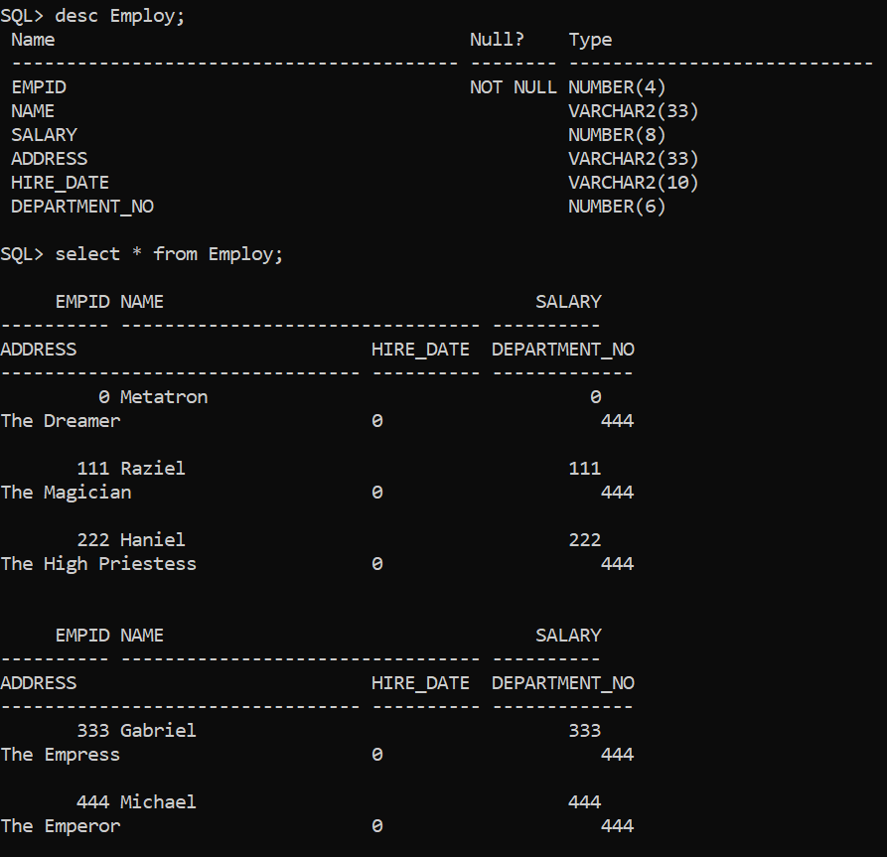

1. **a) Create a table Departments with the columns dept_id,**

**dept_name, loc_name where dept_id is primary key.**

**Ans.**  create table Departments

(

dept_id number(4),

dept_name varchar2(33),

loc_name varchar2(33)

);

alter table Departments

add constraint pk primary key(dept_id);

**b) Create other table locations with the columns location_id,**

**location_name, area where location_id is primary key.**

**Ans.** create table Locations

(

location_id number(5),

location_name varchar2(30),

area varchar2(22)

);

alter table locations

add constraint pk_loc primary key(location_id);

* **Ensure that dept_name should starts with ‘C’.**

alter table Departments

modify dept_name check(dept_name like 'C%');

* **Give appropriate names to all the constraints being imposed on the tables. Insert at least three rows in both the tables.**

insert into Departments values(111,'CSE','Ranchi');

insert into Departments values(122,'CE','Asansol');

insert into Departments values(333,'CCE','Kolkata');

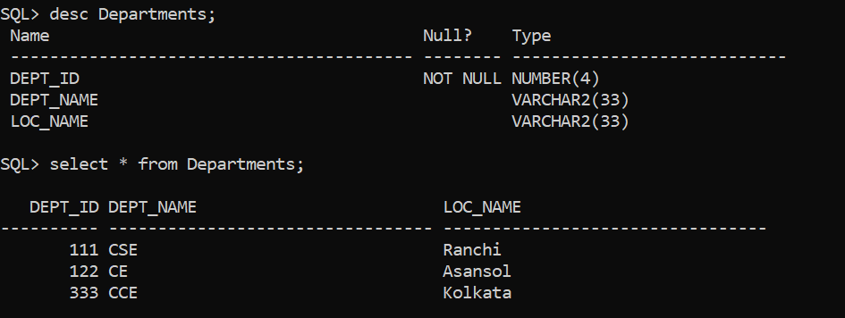

insert into locations values(11,'Ranchi','Jharkhand');

insert into locations values(22,'Asansol','West Bengal');

insert into locations values(33,'Kolkata','West Bengal');

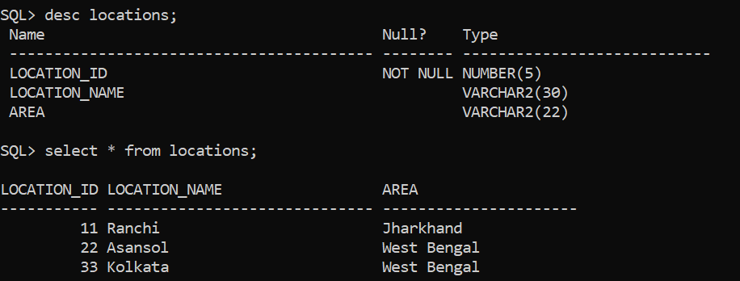

1. **a) Create a table Employees with the columns empid, name,**

**salary, address, hire_date, mgr_no,dept_name where empid is**

**primary key.**

**Ans.** create table Employees

(

empid number(4),

name varchar2(30),

salary number(8),

address varchar2(33),

hire_date varchar2(10),

mgr_no number(6),

dept_name varchar2(33)

);

alter table Employees

add constraint pk_emps primary key(empid);

* **Give appropriate names to all the constraints being imposed on the tables. Insert at least 10 rows in the employees table with different department names .**

insert into Employees values(1,'A',111,'11','11/2/11',11,'CSE');

insert into Employees values(2,'B',222,'22','12/2/11',22,'CSE');

insert into Employees values(3,'C',333,'33','13/2/11',33,'CSE');

insert into Employees values(4,'D',444,'44','14/2/11',44,'CSE');

insert into Employees values(5,'E',555,'55','15/2/11',55,'CSE');

insert into Employees values(6,'F',666,'66','16/2/11',66,'CSE');

insert into Employees values(7,'G',777,'77','17/2/11',77,'CSE');

insert into Employees values(8,'H',888,'88','18/2/11',88,'CSE');

insert into Employees values(9,'I',999,'99','19/2/11',99,'CSE');

insert into Employees values(10,'J',1010,'1010','20/2/11',1010,'CSE');

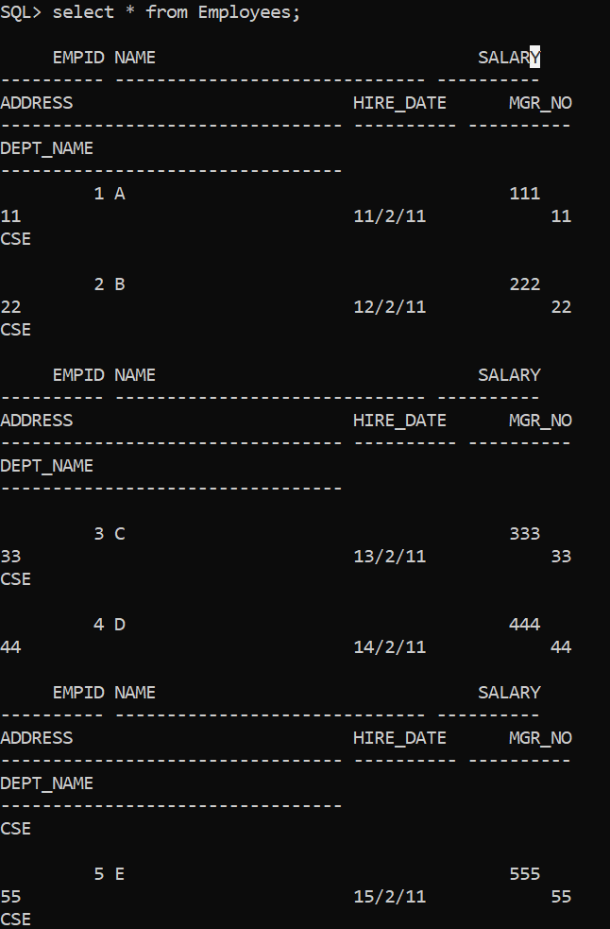

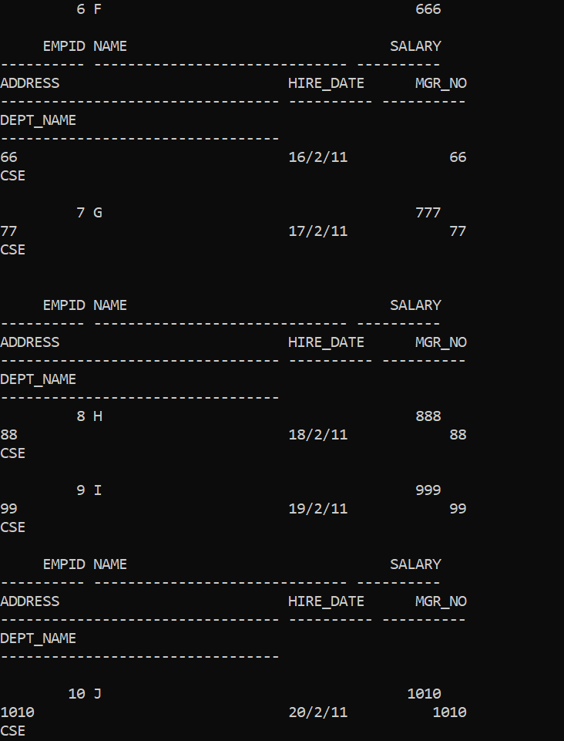

1. **Create the Following Branch table with the record given below. The underline column is the primary key.**



**Ans.** create table Branch

(

bname varchar2(33) primary key,

bcity varchar2(7),

assets number(3)

);

insert into Branch values('pu','Pton',10);

insert into Branch values('nyu','nyc',20);

insert into Branch values('time sq','nyc',30);

1. **Create the Following Account table with the record given below. The underline column is the primary key and bname will be the foreign key.**



**Ans.** create table Account

(

bname varchar2(33),

acctn number(3) primary key,

bal number(4),

foreign key(bname) references Branch(bname)

);

insert into Account values('pu',33,356);

insert into Account values('nyu',45,500);

1. **Find names of branches which have balance greater than 500.**

**Ans.** select bname from account

where bal>500;

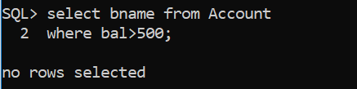

1. **Create the Following Customer table with the record given below. Make acctn as foreign key.**

|  |  |  |
| --- | --- | --- |
| Cust_id | Acctn | Cust_name |
| 22 | 33 | Suresh |
| 25 | 45 | Amit |
| 30 | 60 | Ayantika |

**Ans.** create table Customer

(

Cust_id number(3),

acctn number(3),

Cust_name varchar2(33),

foreign key(acctn) references Account(acctn)

);

insert into Customer values(22,33,'Suresh');

insert into Customer values(25,45,'Amit');

1. **Alter the Customer table to insert primary key for Cust_id.**

**Ans.** alter table Customer

add primary key(Cust_id);

1. **Display acctn and Cust_name for cust_id 22.**

**Ans.** select acctn, Cust_name from customer

where Cust_id = 22;

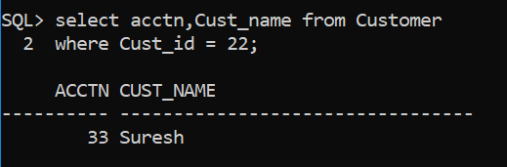

1. **Display those branch name(bname) which is located in nyc.**

**Ans.** select bname from Branch

where bcity = ‘nyc’;

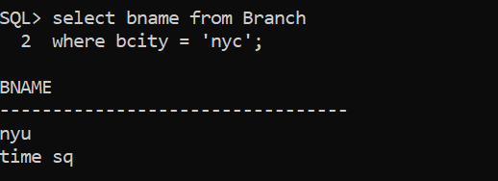

1. **Display all the tables.**

**Ans.** select * from Branch;

select * from Account;

select * from Customer;

